

SUMMARY

The investors request the following information:

1. Presentation of the company: Main products, competitors, main shareholders, and the main business segment.
2. Compute the following ratios for the years 2019 to 2021.
   1. The operating margin
   2. Net profit margin
   3. Working capital
   4. Return on equity.
   5. Current ratio
   6. Quick ratio
   7. Debt to equity ratio
3. Conclusion
4. Sources & data collection
5. **Presentation of the company (Main products, Competitors, main shareholders, and the main business segment).**

**Introduction**

Walmart's strategy is to make life easier for busy families by providing price leadership and increasing convenience. They serve approximately 230 million customers each week through their retail stores and eCommerce websites in 24 countries. Walmart's pricing philosophy is everyday low prices (EDLP) and everyday low cost (EDLC) to control expenses and pass savings along to their customers.

Walmart has also been making strides towards becoming more digital, recognizing the importance of omni-channel offerings that save time for customers. The company's commitment to trust as a competitive advantage has also been a key focus, with a goal of sharpening their culture to better serve customers. With a broad assortment of quality merchandise and services, Walmart continues to lead on price and make life easier for busy families around the world.

**Main products:**

Walmart offers a wide range of products including groceries, apparel, electronics, home goods, and other consumer goods. The company is also known for its private label brands, such as Great Value and Equate, which offer customers a lower-priced alternative to national brands. Walmart also operates a variety of subsidiaries, including Sam's Club, a membership-based wholesale store, and Walmart International, which operates in various countries around the world.

**Competitors:**

Walmart's main competitors include other large retailers such as Amazon, Target, Costco, and Kroger. In addition to these retail giants, Walmart also faces competition from smaller, local retailers in various markets around the world. These companies also offer a variety of products and services to their customers and compete with Walmart in different ways.

**Main shareholders:**

As of the most recent filings with the US Securities and Exchange Commission, Walmart's largest shareholders include the Walton family, who collectively own approximately 50% of the company's outstanding shares. Other major shareholders include institutional investors like BlackRock (4,8%), Vanguard Group State Street Corporation (5,6%), and Berkshire Hathaway.

**Main business segment:**

Walmart operates in three main business segments: Walmart U.S., Walmart International, and Sam's Club. Walmart U.S. includes the company's retail operations in the United States, which accounted for approximately 65% of the company's total revenue in 2021. Walmart International includes the company's operations outside of the United States, while Sam's Club is a membership-only warehouse club that offers bulk products to its members. The company also has a growing e-commerce business, which includes its online marketplace and grocery delivery service. Additionally, Walmart operates stores and e-commerce sites in various international markets, including Canada, Mexico, China, and the United Kingdom.

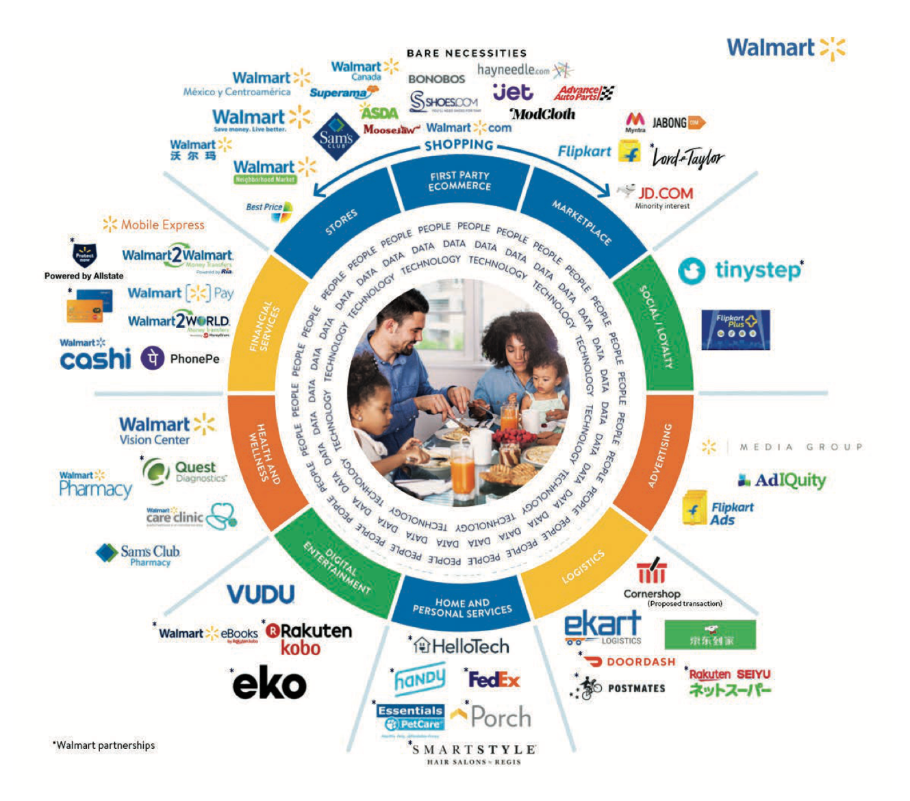

1. **Operating margin : Operating profit/Revenues**

* billions USD

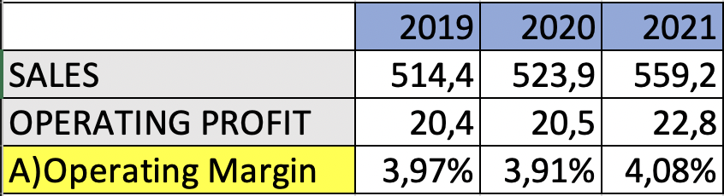

The operating margin measures the amount of revenue that is left after subtracting the operating expenses, we can see that Walmart’s operating margin is low, this is because of its business model.

Walmart operates a low-cost business model which allows it to maintain a healthy and profitable operating margin compared to its competitors in the industry. During the period 2019-2021 we can see that the operating margin was around 4 and it remained stable, this means that Walmart generated approximately $0,004 for every dollar of revenue it generated from its operation during those years. What is also surprising is that their operating margin only decreased with 0,06 Percentage points during COVID In 2020.

However, after the COVID-19 period in 2021 the operating margin increases to 4,08% which indicates that Walmart increased its revenues or decreased its expenses at a faster rate than its operating income, most of the times this is seen as a positive sign since it indicates that the company is being more profitable.

B)**Net profit margin: Net profit/sales**

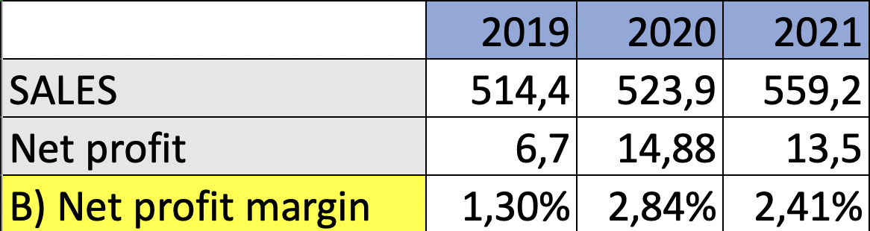

Walmart experienced a net profit margin of 1.30% in 2019, which increased to 2.84% in 2020. In 2021, the net profit margin slightly decreased to 2.41%. These figures suggest that Walmart was able to improve its profitability in 2020, most likely due to the increased demand during the COVID-19 pandemic. However, the company faced some challenges in 2021. It's important to note that net profit margin is just one measure of a company's financial performance and doesn't provide a complete picture.

C)**Working capital: Current assets-current liabilities**

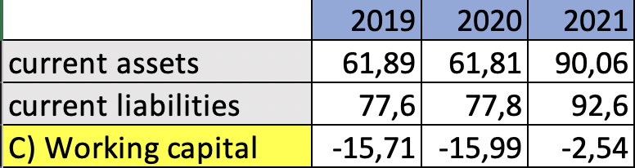

working capital is a way to measure a company's financial situation short term.

Walmart's working capital is negative during the analyzed period 2019-2021. Having a negative working capital does not necessarily mean that the company is not financially healthy or stable.

In walmart´s situation the working capital can be most of the times negative because of its low level of inventory due to its business model of moving inventory as fast and efficiently as possible, which consists of reducing cost and increasing efficiency by keeping low levels of inventory.

Walmart´s short-term financing strategies also can be a cause for its negative working capital, having a powerful cash position and access to credit lines, allows it to control short-term liabilities effectively.

However, in 2021 the working capital increased significantly and was only -2,52 billion compared to the previous two years that were -15 billion due to a drastic increase in its current assets, which means that Walmart has more resources to support its daily activities

**D) Return on equity: Net income/shareholder´s equity**

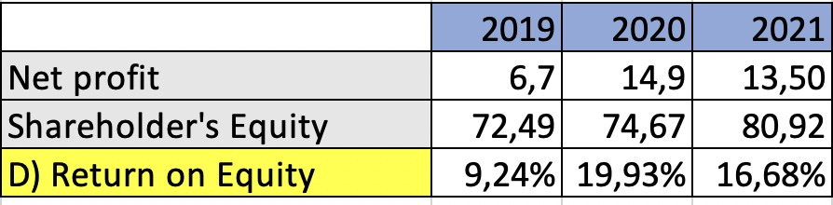

Owners and investors can gain insight into the company's profitability. In short, it helps investors understand whether they're getting a good return on their investment, and it's also a great method for evaluating how effectively the company can use the firm's equity.

Walmart was able to produce larger profits for every dollar of invested shareholder equity, as can be shown by the fact that its ROE increased significantly in fiscal year 2020 compared to the financial year 2019, as can be seen. Although it remained at a high level, the ROE did slightly decline in 2021.

Overall, Walmart's ROE seems to be stable and robust, indicating that the company is successfully making good use of the equity that shareholders have placed in it to generate profits.

**E) Current ratio: Current assets/current liabilities**

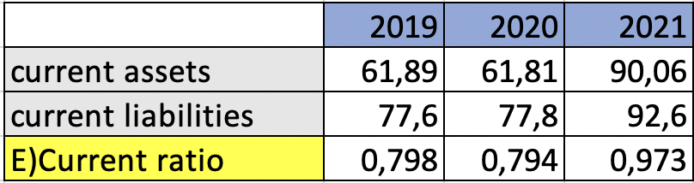

The current ratio is a financial ratio that measures a company's ability to pay its short-term liabilities using its current assets.

According to the analysis above, Walmart's current ratio was relatively constant in 2019 and 2020 but increased in 2021. The improvement in 2021 is positive and shows that Walmart was better capable of covering its  current liabilities with its short-term/current assets.

Usually it is desirable that the current ratio of a company is higher or equal to 2, for walmart this was not the case during the years 2018, 2019 and 2018, it does not mean that walmart did not meet its short-term obligation, due to its strong cash balance and credit rating they were able to meet these.

Thus, it is important to take into account that the current ratio depends on the industry, in retail companies such as  Walmart it is typical to have lower current ratios due to its business model, which involves a high level of inventory turnover

**F) Quick ratio: (Current assets-inventory) /current liabilities**

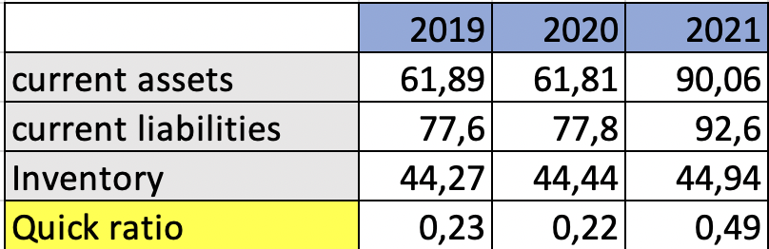

financial ratio that measures a company's ability to use its quick assets (which are assets that can be easy converted into cash)to pay its short-term liabilities

Walmart's quick ratio was 0.22 in 2019, but it fell to 0.19 in 2020. This demonstrates that Walmart's ability to meet its short-term liabilities with its short-term assets decreased slightly in 2020 compared to 2019. Covid-19 could have been a cause of the decrease in the quick ratio as a result in increased inventory levels and lowers sales. In addition, Walmart invested a lot in technology and e-commerce capabilities during that year, which also affected the company's liquidity position.

However, in 2021 the quick ratio increased drastically to 0,49 one of the main reasons for this change was the increment in its current assets such as cash reserves. Nevertheless, as previously mentioned it is important to take into account the industry you are in, especially since usually a quick ratio  equal to 1 or higher is considered a good ratio which is not the case for walmart.

**G) Debt to equity ratio: Total liabilities/total shareholders’ equity**

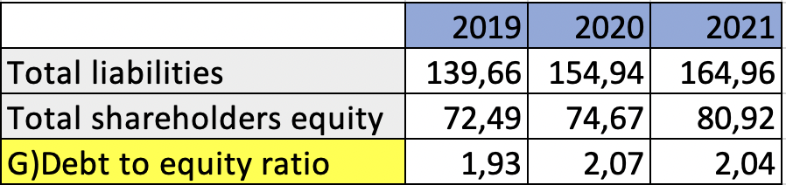  
  
The debt-to-equity (D/E) ratio is a financial measurement that compares the amount of debt used to finance a company's operations to the amount of equity.

For Walmart, during the period analyzed above we can see a high D/E ratio, it indicates that the company is dependent on debt and heavily reliant on debt to finance asset purchases. which means that the company is financing asset purchases with more debt than equity, nevertheless, compared with a key competitor such as Target whose D/E ratio was around 3,9 around that period Walmart had a lower D/E ratio.

It is important to note, however that a high D/E ratio does not always indicate that a company is in financial trouble. The relevance of a high D/E ratio is determined by the company's industry and business model, as well as its capacity to meet its debt obligations through earnings and cash flow.

**Conclusion**

Walmarts main strategy is everyday low prices (EDLP) and everyday low cost (EDLC). Walmart offers a wide range of products, including private label brands. Walmart's financial model is focused on providing low-priced products to customers while maintaining high operational efficiency. This is achieved through Walmart's use of technology, supply chain management, and cost-cutting, which allow the company to offer competitive prices to consumers while maximizing profits. They also diversify revenue streams, which helps to mitigate risk and provide stable growth opportunities. Overall, Walmart's financial model is centred around operational efficiency and cost management, which allows the company to remain competitive in the retail industry.

**Bibliography**

*Walmart Corporate News and Information*. (s. f.). Corporate - US. [https://corporate.walmart.com](https://corporate.walmart.com/)

*WMT | Walmart Inc. Annual Cash Flow Statement*. (2023, 15 march). MarketWatch. [https://businesschronicler.com/competitors/walmart-competitors-analysis/](https://www.marketwatch.com/investing/stock/wmt/financials/cash-flow)

Mahato, A. K. (2022, 30 noviembre). *Walmart Case Study | Walmart Marketing Strategy*. StartupTalky. <https://startuptalky.com/case-study-of-walmart/>

Walmart Income Statement. Retrieved from

<https://www.marketwatch.com/investing/stock/wmt/financials/cash-flow>

Walmart Cash flow. Retrieved from <https://www.wsj.com/market-data/quotes/WMT/financials/annual/balance-sheet>

Balance sheet

